**Introduction to JAVA1**

**Date 15/02/2021**

Q1. Write a program to replace a substring inside a string with other string? 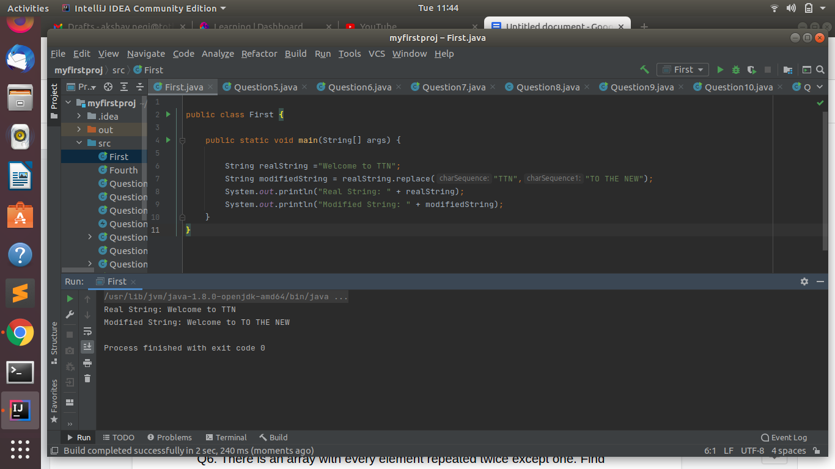

Q2. Write a program to find the number of occurrences of the duplicate words in a string and print them ?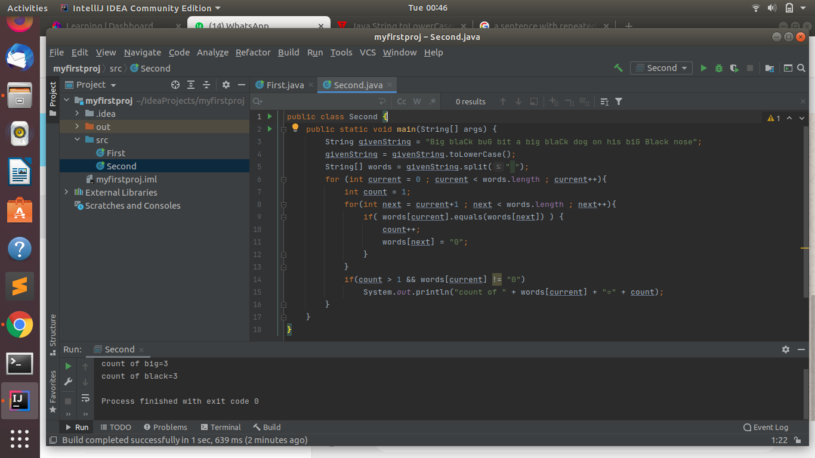

Q3. Write a program to find the number of occurrences of a character in a string without using loop?

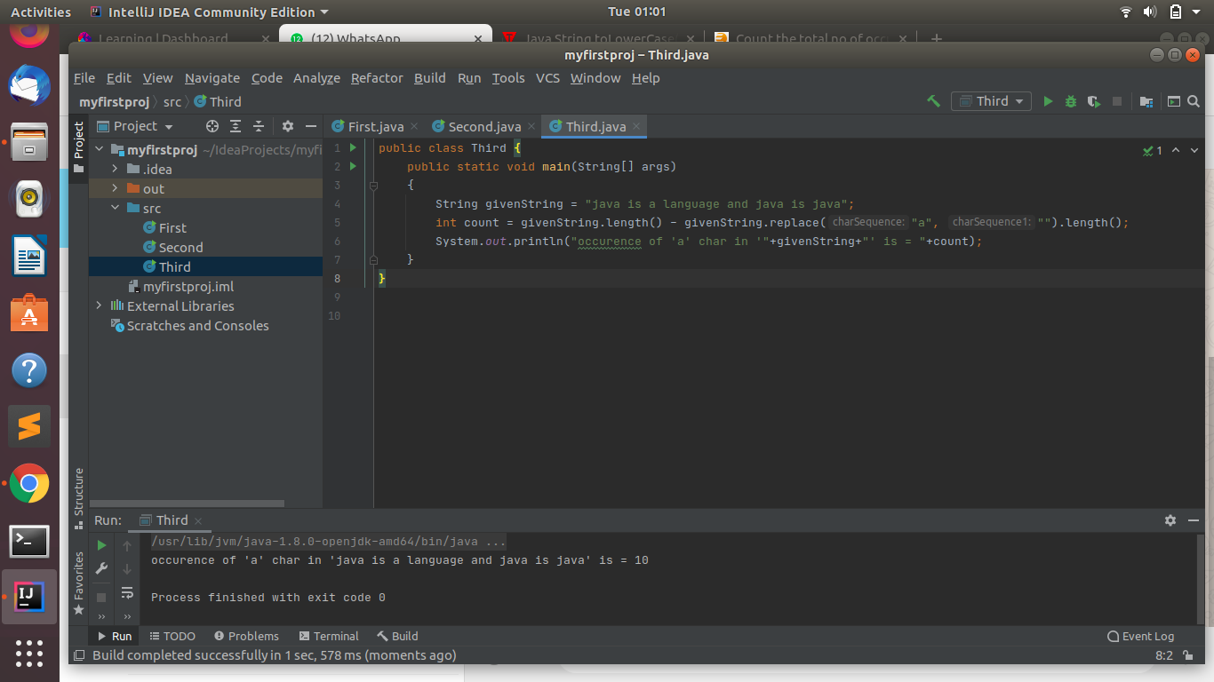

Q4. Calculate the number & Percentage Of Lowercase Letters,Uppercase Letters, Digits And Other Special Characters In A String

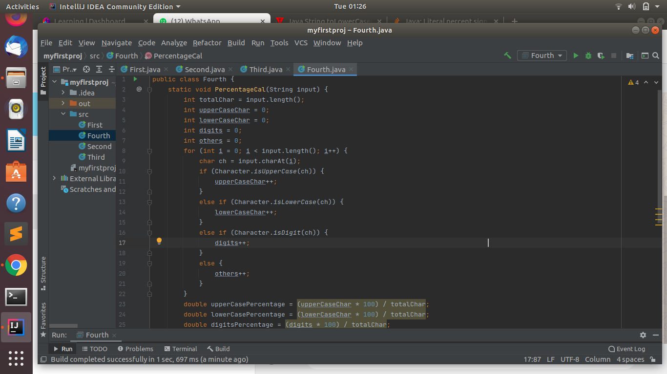

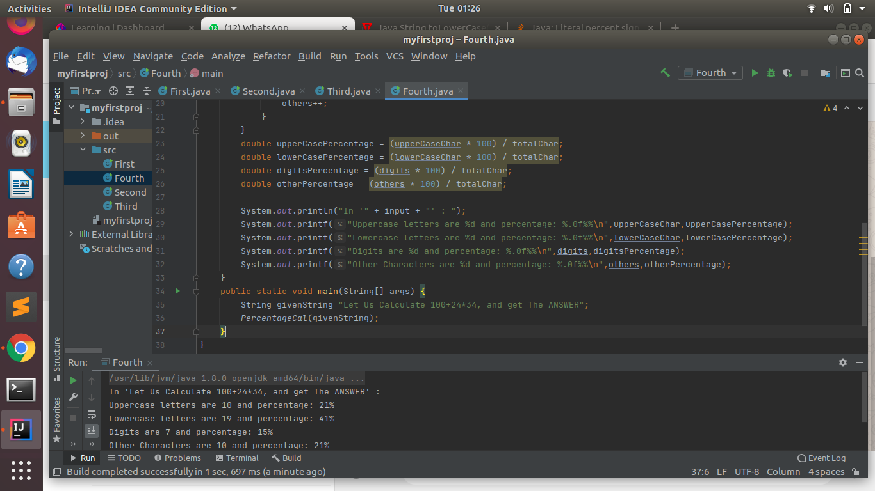

Q5. Find common elements between two arrays.

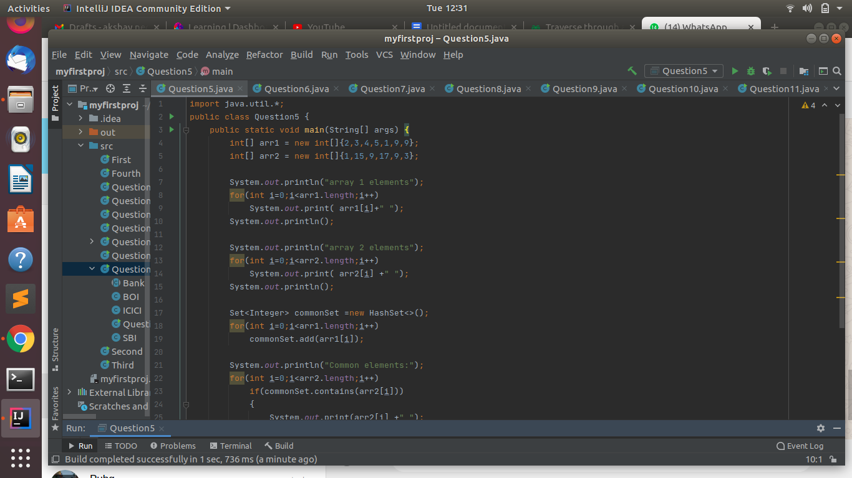

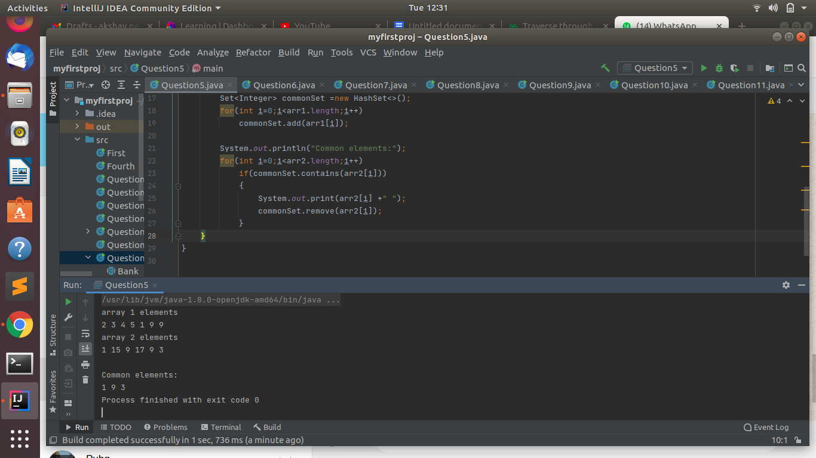

Q6. There is an array with every element repeated twice except one. Find that element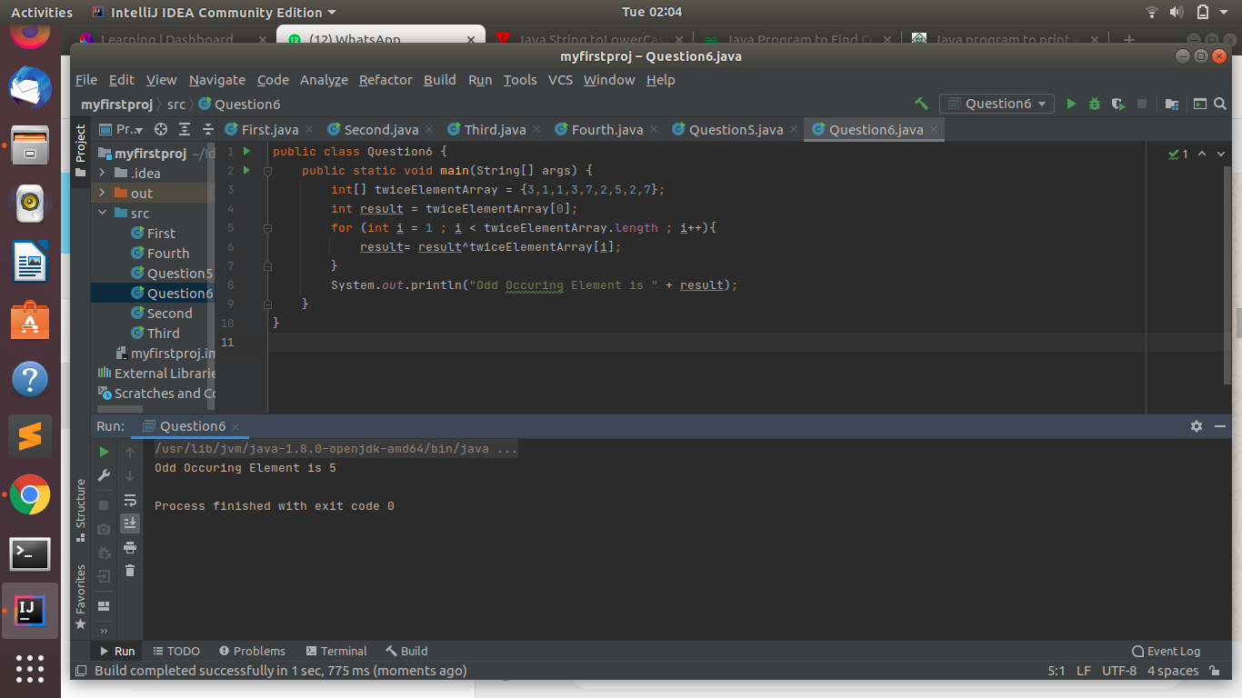

Q7. Write a program to print your Firstname,LastName & age using static block,static method & static variable respectively.

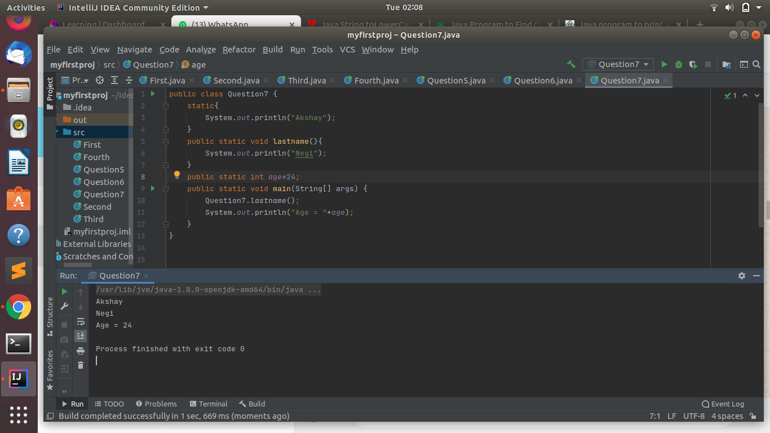

Q8. Write a program to reverse a string and remove character from index 4 to index 9 from the reversed string using String Buffer

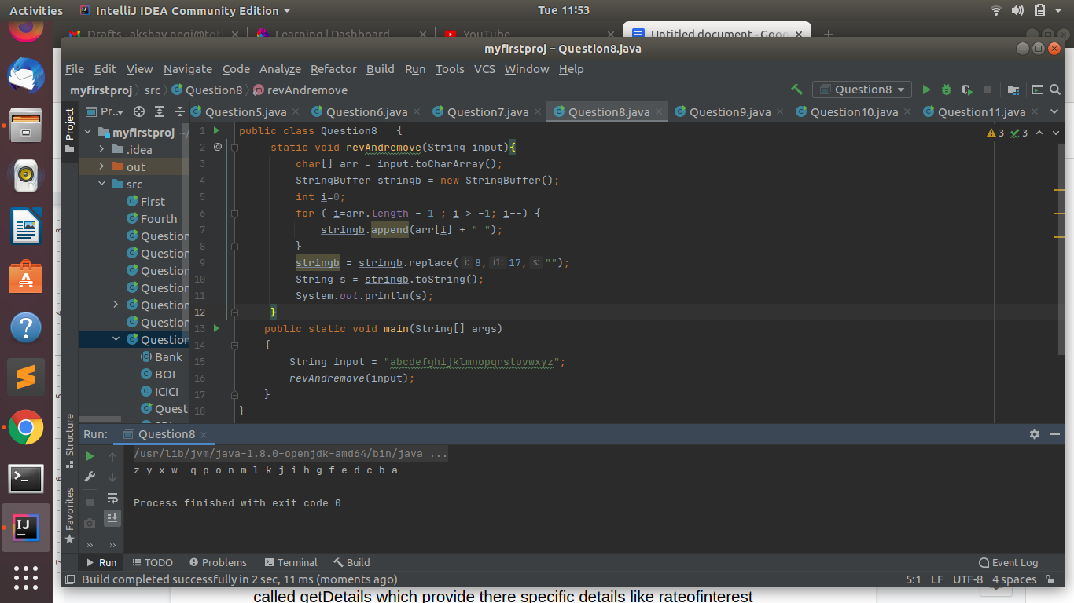

Q9.Write a program to display values of enums using a constructor & getPrice() method (Example display house & their prices).

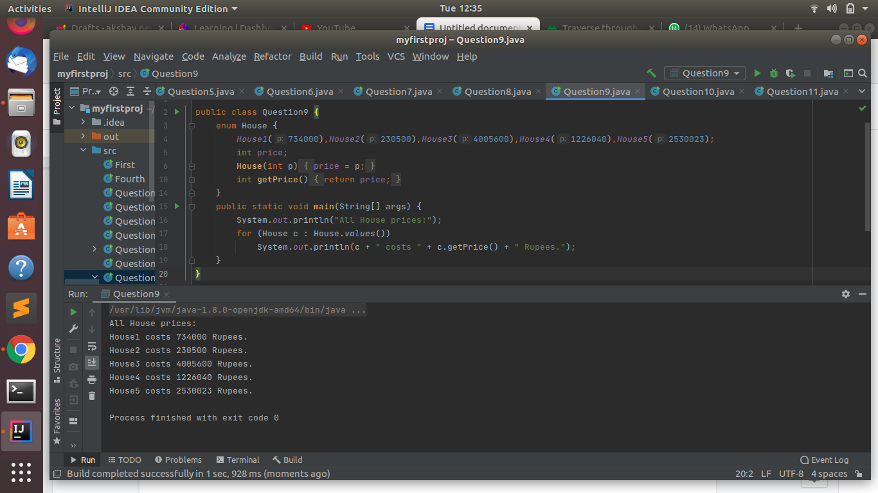

Q10.Write a single program for following operation using overloading

A) Adding 2 integer number

B) Adding 2 double

C) multiplying 2 float

D) multiplying 2 int

E) concate 2 string

F) Concate 3 String

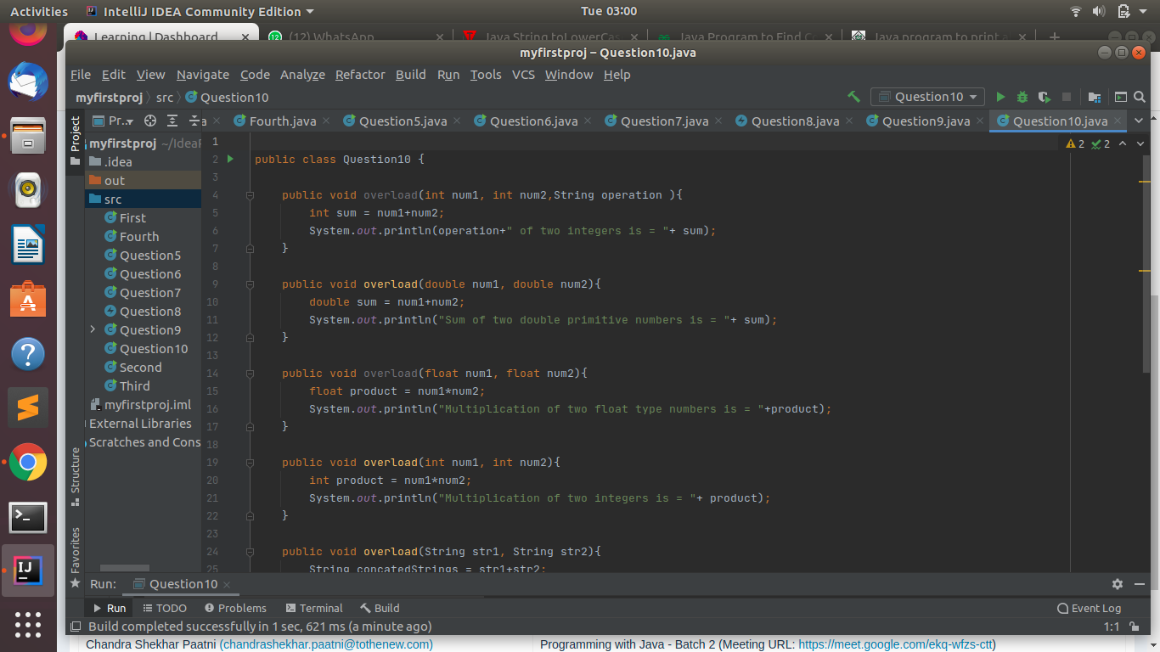

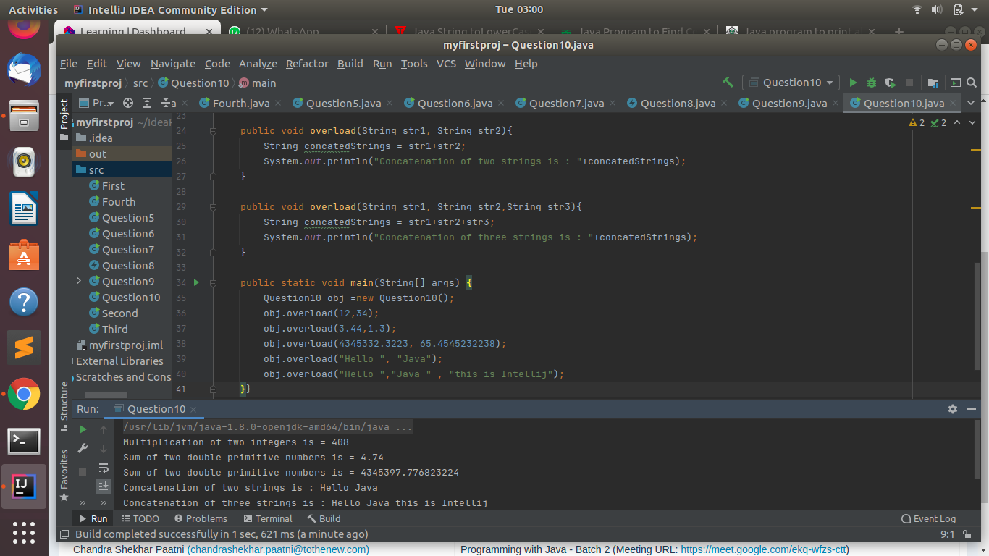

Q11.Create 3 sub class of bank SBI,BOI,ICICI all 4 should have method called getDetails which provide there specific details like rateofinterest etc,print details of every banks.

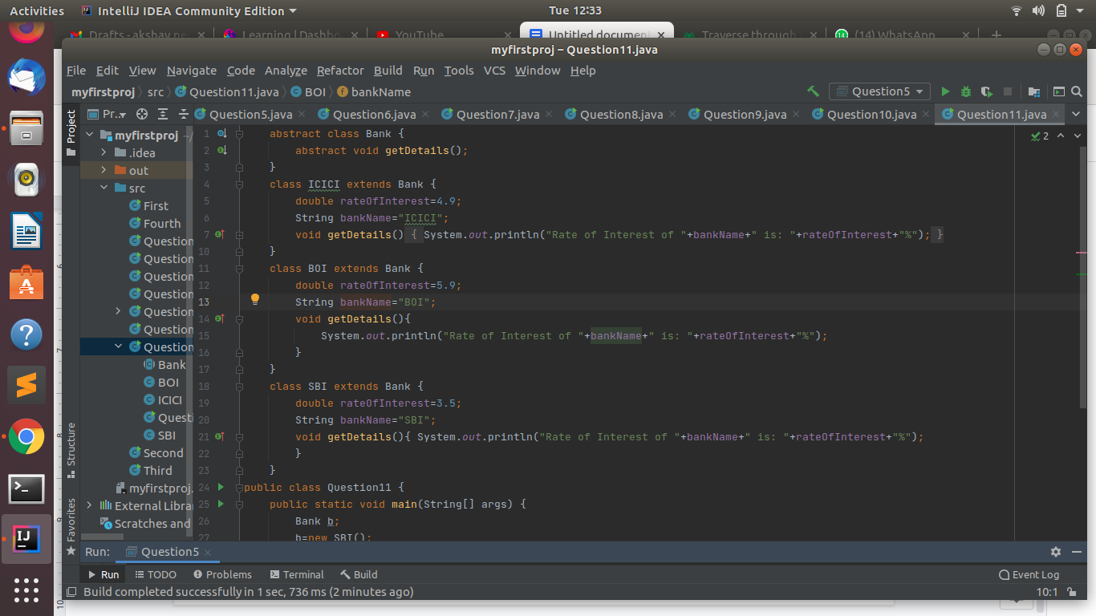

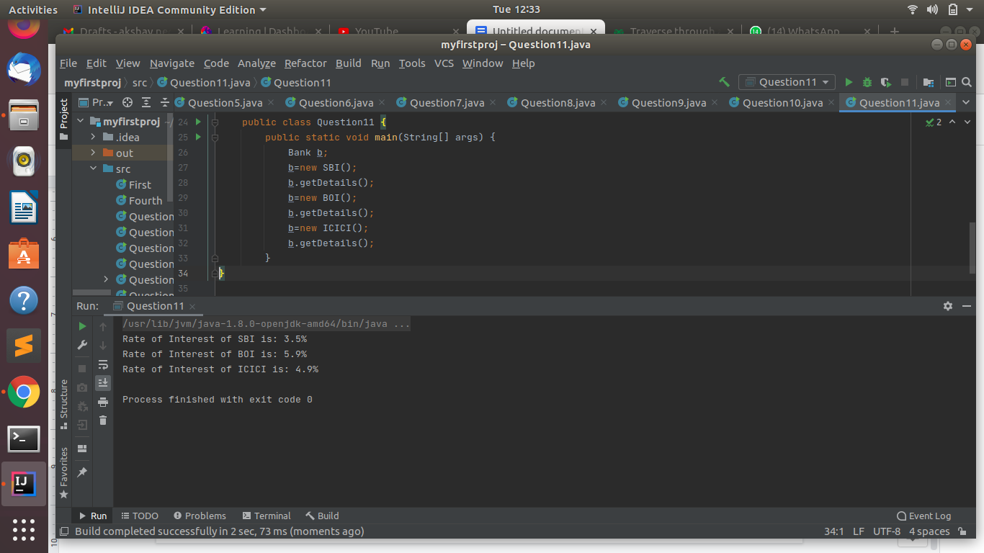

Google doc link: <https://docs.google.com/document/d/1GZy5wXuimhI5_DdbU3Uv34saTx-Dx-ZZsI7o03J9XyE/edit?usp=sharing>